Title: Lalala

Who: Thomas Vu, Cristian Mendivil, Ryan Bravdica, Chad Kessler, Nicholas Sugarman

Project Tracker:

Link: <https://trello.com/b/rURe1UK0/sofgame>

Screenshot:

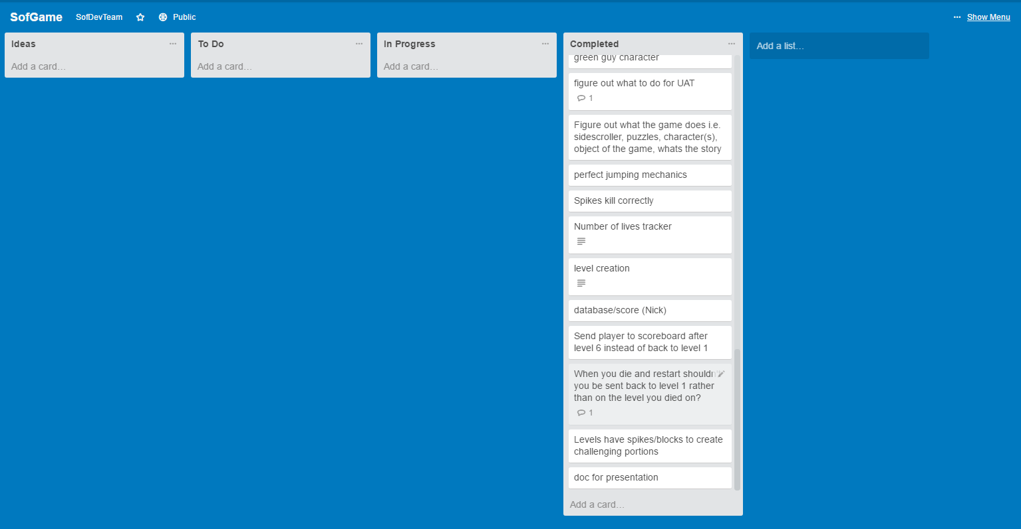

VCS Repository: